# Executive Summary

After interviews with HSQE team regarding:

* Enhancing Safety Inspection Procedures.
* Accessing Standard Operating Procedures.
* Keeping track of user training and sending user reminders before their training expires.

Shortfalls were found with **Google Forms** and **Eclipse Training**.

3 solutions listed below were demoed and ranked. 0(Unacceptable) to 3(Exceeds Expectations):

|  |  |
| --- | --- |
| **Solution** | **Ranking** |
| Velocity EHS |  |
| BIS Safety |  |
| Spence Software |  |

While both Velocity EHS and BIS Safety meet the functional requirements, it is recommended that Velocity EHS/BIS Safety be selected and implemented at **Squamish**, **Lynnterm** and **Coast2000** terminals. That is because Velocity EHS has a pricing that matches our budget and the functionalities for SOP forms, Audit Inspection and Training Tracking are decent enough based on our needs. The other main contender, BIS Safety, has a more user-friendly interface and the best functionality overall, however, due to their transactional pricing model, and after calculating our usage, their software becomes much more expensive and so they are not the ultimate choice. That is because even though both Velocity EHS and BIS Safety have good enough functionalities, BIS Safety has a phenomenal user interface and therefore, it will be more comprehendible for not only HSQE team but also new users such as Foremen. The implementation of Velocity EHS/BIS Safety is estimated to take a months. The licensing costs for Velocity EHS to support these terminals is estimated to be b in year 1 and c annually in subsequent years.

The following sections contain supporting details for recommendations. This includes a summary of findings during selection process, and a breakdown of how the current rankings were calculated.

Table of Contents

Executive Summary 1

The Background 4

Current system shortfalls 4

Project Scope 4

Phase 1(September 2021) 4

Phase 2(October 2021) 4

Grading Criteria 4

Stakeholders 5

User Definition – Difference between Trainee and User – Different types of Trainings 5

Rankings 6

Functional Fit – Business Requirements 6

Ease of Use 6

Annual Costs 7

Implementation Costs 7

Technical Fit 7

Vendor Fit 7

Recommendations 7

Next Steps 7

Appendix 1 – Requirements Document 8

Appendix 2 – Demo Outline 10

Appendix 3 – Ranking Summary 11

Appendix 4 – Using 6 Scenarios to Compare the Transactional plus User-based Pricing of BIS Safety Versus the Constant Pricing of Velocity EHS 12

• Scenario 1: Use Digital Forms and Assets in User Based Pricing for 200 Users + Use 2000 Training Records and have 1000 people who complete a course in Learning Management using Transactional Pricing in Transactional Pricing. 12

• Scenario 2: Use Digital Forms and Assets in User Based Pricing for 200 Users + Use 2000 Training Records in Transactional Pricing. 12

• Scenario 3: Use Digital Forms and Assets in User Based Pricing for 500 Users + Use 2000 Training Records in Transactional Pricing. 13

• Scenario 4: Use Digital Forms in User Based Pricing for 500 Users + Use 2000 Training Records and 200 Asset Forms in Transactional Pricing. 13

• Scenario 5: Nothing in User Based Pricing + Use 2000 Training Records, 500 Digital Forms, and 200 Asset Forms in Transactional Pricing. 13

• Scenario 6: Use Training Records in User Based Pricing + 500 Digital Forms, and 200 Asset Forms in Transactional Pricing. 14

Appendix 5 - Pros and Cons of each Contender based on Collected Surveys 15

# The Background

## Current system shortfalls

**Google Forms** **for Inspections**: The forms are easy to use, however:

* It is difficult to focus in on “bad answers”.
* Not possible to assign corrective actions.
* Not possible to generate reports.

**Eclipse Training**: To hold a variety of video training, also keeps track of training completion dates, however:

* Training tracking does not cover every type of training including in person training.
* Not possible to send auto reminders. HSQE team must check the data manually.
* Does not support uploading external training certificates.

## Project Scope

Phase 1(September 2021): Needs Assessment interview with stakeholders involved:

* A functional requirements document, as found in Appendix1. Main requirement categories are Functional Fit, Ease of Use, Technical Fit and Vendor Fit.
* Calls to top EHS companies from **Green Quadrant 2019** report to price check and find 3 to present a demo to stakeholders.
* A demo outline based on requirements, as found in Appendix2, and it was sent to vendors prior to presentations.

Phase 2(October 2021): Select from 3 solutions involved:

* a kickoff meeting to go over the project scope with stakeholders.
* Scheduling a demo for each vendor.
* Summarizing scores given and preparing a recommendation report

Following completion of the project, stakeholders will convene to review the final report and make a Go/No-Go decision.

## Grading Criteria

The following are the criteria and their weightings:

|  |  |
| --- | --- |
| **Criteria** | **Weight** |
| Functional Fit- Business Requirements | 40% |
| Ease of Use | 10% |
| Annual Costs | 20% |
| Implementation Cost | 10% |
| Technical Fit | 10% |
| Vendor Fit | 10% |
| **Total** | **100%** |

## Stakeholders

Outlined are the staff that participated in the evaluations: (separate HSQE team and IT team)

|  |  |  |  |  |
| --- | --- | --- | --- | --- |
| **Western Stevedoring: HSQE Team** | **Western Stevedoring: IT Team** | **Western Stevedoring: HR Team** | **Squamish Terminal** | **Coast200 Terminal** |
| Darcy Hinds | Roger Dias | Michelle Levangie | Emma Jarret | Darcy Nichols |
| Nelia Willis | Tom Portfors |  |  |  |
| James Prasad |  |  |  |  |
|  |  |  |  |  |
|  |  |  |  |  |

In October 2021, vendor demos took place and the information received from stakeholders was utilized to complete the rankings that follow.

## User Definition – Difference between Trainee and User – Different types of Trainings

HSQE Team utilizes this software to administrate and manage the users, namely, sending trainings to employees, oversee the inspections, and making sure everyone has anonymous access to SOP forms. IT Team makes sure the software is running with no technical problems. Different types of users include but are not limited to:

* Training Tracking Users:
  + Foremen.
  + Regular Workforce.
  + Consultants.
  + Regular Staff.
  + Truckers (Through Eclipse)
  + Contractors (Through Eclipse)
* Inspection Users:
  + Foremen.
* SOP Users: Everyone with an access link. This includes all employees including the ones who work on site and require a quick training.

Types of Trainings:

* Fall Arrest Training.
* Violence Training.
* 3rd Party Training.
* Emergency Response Training.
* Foreman Training.
* SOP Training.
* Policy Training – Review.
* In-house training.
* External training by External Instructors.

# Rankings

The following, based upon a score of 0 (Unacceptable) to 3 (Exceeds expectations), are the final rankings of each solution:

|  |  |
| --- | --- |
| **Solution** | **Ranking** |
| Velocity EHS |  |
| BIS Safety |  |
| Spence Software |  |

While a summary of each component ranking for each vendor is found in Appendix 3, the following provides some details regarding each ranking.

## Functional Fit – Business Requirements

Following the demo of each solution, the evaluators provided a ranking as to how they felt the solution meet the business requirements outlined in the demo script.

|  |  |
| --- | --- |
| **Solution** | **Ranking** |
| Velocity EHS |  |
| BIS Safety |  |
| Spence Software |  |

BIS Safety and Velocity provided temporary logins for testing and based on the feedback, BIS Safety was undoubtedly the best system matching our scope and one of the reasons it was considered superior compared to Velocity is the room is the Incident Investigation module. Velocity EHS does not have a separate module for Incident Investigation and Inspection forms must be used because they have similar functionality, however, BIS Safety does have a separate module for it.

Spence was disregarded early in the process mainly because their mobile app was not ready to use yet, and even if it was, they did not have functionality for Training Tracking and a few other modules.

## Ease of Use

The evaluators also provided a ranking as to how they felt the solution was easy to use.

|  |  |
| --- | --- |
| **Solution** | **Ranking** |
| Velocity EHS |  |
| BIS Safety |  |
| Spence Software |  |

Both Velocity and BIS Safety met the threshold of being easy to use, however, BIS was more highly regarded because of use of different colors in their software and the menus being generally easier to use. As for Spence, they were disregarded quite early in the process mainly because their web app had a complicated flow to follow.

## Annual Costs

Details (data list and visual chart) (breakeven analysis) (future scope – future projection appendix, talk Roger – what if analysis)

## Implementation Costs

Details (data list and visual chart) (breakeven analysis) (future scope – future projection appendix, talk Roger – what if analysis)

## Technical Fit

How it is evaluated – Details

## Vendor Fit

An approximate measurement of how the company will fit with Western Stevedoring. Determined based on demos by Homa Banazadeh and averaged with Vendor Fit score given by Stakeholders, so Homa’s scoring contributes 50% and so does the average for stakeholders.

|  |  |  |  |
| --- | --- | --- | --- |
| Criteria | Velocity EHS | BIS Safety | Spence |
| Long-term viability | 7 | 7 | 3 |
| Customer service | 8 | 10 | 5 |
| How well we fit as their target client | 8 | 8 | 3 |
| Culture fit | 10 | 10 | 10 |
| Will they be providing an Account Manager? | 10 | 10 | 10 |
| How was their demonstration? | 5 | 7 | 8 |
| How are their reference clients? | 0 | 0 | 0 |
| **Average Score** | 6.85 | 7.42 | 5.5 |

# Recommendations

Details

# Next Steps

Incident Investigations and Corrective Actions was mentioned during after demo discussions as 2 of most important modules to have and

Sharepoint for SOP forms software behind sign-up

# Appendix 1 – Requirements Document

**Functional Fit (Requirements)**

* SOPs, Audit Inspection, Incident Investigation.
  1. Ability to create **customizable forms**.
  2. Analytics on Inspection forms: **“bad answers” need to stand out** and a report from bad answers can be generated.
  3. **Print** each completed Inspection form in **PDF**.
  4. Management can assign **corrective actions** when an Inspection form contains a “bad answer”.
  5. Management can be **reminded via email when a response is no**. Employee can be reminded when a corrective action is assigned.
  6. SOP Documents:
     + **can be uploaded** in the new system.
     + have **version control** capability.
     + come with **anonymous access** (no authentication required).
     + can be accessed with a **dynamic QR code**.
     + in the new system can be **linked to our website**.
  7. Inspections are conducted in a personalized and dynamic form, so **if an answer is no, more related questions can be asked** in that form.
  8. (Optional) **Inspection Scheduling**.
  9. (Optional) **Incident Investigation** capability.
* Training Tracking & LMS Solution.
  1. Attach **proof of attendance.**
  2. Review and sign the **policy.**
  3. Set **expiry date** for a certain training, send **reminders** to both employees and management when expiry date is near.
  4. **Record** employee training datain a database. Management can add to that database any information, and an employee can also add their records of courses that they have completed in different platforms.
  5. **Schedule classes** by management and assign to a **group** of employees, assign by role or age. Not every class will be scheduled.  **Not required but nice to have. Make a not if it does not have it.**
  6. Standalone **training platform** with custom course design.
  7. **Employee profile** contains all the information about that employee as well as all the certificates he/she has uploaded.

**Ease of Use**

* For SOPs & Audit Inspections:
  + Inspection forms and SOP documents are **mobile and tablet friendly**.
  + **Analytics reporting,** how revision control works for the author. Role definition, can the author publish the report for others to use/customize?
* For Training Tracking & LMS Solution:
  + Management can easily **identify who is about to expire**, using a report or a visual.
* **General user friendliness**.

**Technical Fit**

* **Data import/export** capability using an API, SQL, other software.
* **Direct access to their database or the ability to schedule exports**, for Power BI.
* **Customizable Reports.**
* **Single sign-on authentication** using MS Azure AD
* **Cloud based**.

**Vendor Fit**

* Overall **presentation impression**.
* **Prices go up with inflation rate only.**
* Service providing long-term viability based on how many **years** they have been in the industry and **how many customers** they have.
* Level of **customer service** based on **amount and quality of availability**, whether it is **24/7 or office hours only**.
* The ability to **support the monthly quantity of inspection forms filled (about 30 inspection forms per month)**, and trainings assigned without technical difficulties.
* Possibility of having an **account manager**, a person to reach out to for customer service.
* Quality of **reference clients**.

# Appendix 2 – Demo Outline

**Demo Outline**

Duration: **60 minutes**.

**First 45 minutes**:

* Company history. **(5 minutes)**
* Audit Inspections support and SOPs. **(15 minutes)**
  + Filling the forms.
  + How “bad answers” stand out and how the reporting system works.
  + Corrective actions to assign when encountering “bad answers”.
  + Customizability of each form.
* Training Tracking & LMS solution. **(15 minutes)**
  + Proof of attendance.
  + Review and sign the policy.
  + Reporting system functionality for keeping track of expiry date and sending reminders to manager and employee.
  + Schedule classes and assign them based on role or individual.
* Other functionalities. **(5 minutes)**
  + Data import/export capability.
    - Direct access to the database or the ability to schedule exports for Power BI.
    - Is the data stored in Canada, if not where?
    - Customizable reports. How revision control works for the author? Role definition, can the author publish the report for others to use/customize?
  + Single sign-on authentication using MS Azure AD.
  + Customer support for when an employee is facing technical difficulties.
    - Do they have 24/7 customer support available and is a dedicated support named contact available?
* Safety Operation Forms (SOP) support. **(5 minutes)**
  + Version control.
  + Anonymous access.
  + Can we link these forms to our website?

**Last 15 minutes:**

* Questions.
* Time permitted: Incident Investigation.

# Appendix 3 – Ranking Summary

Details

# Appendix 4 – Using 6 Scenarios to Compare the Transactional plus User-based Pricing of BIS Safety Versus the Constant Pricing of Velocity EHS

## Scenario 1: Use Digital Forms and Assets in User Based Pricing for 200 Users + Use 2000 Training Records and have 1000 people who complete a course in Learning Management using Transactional Pricing in Transactional Pricing.

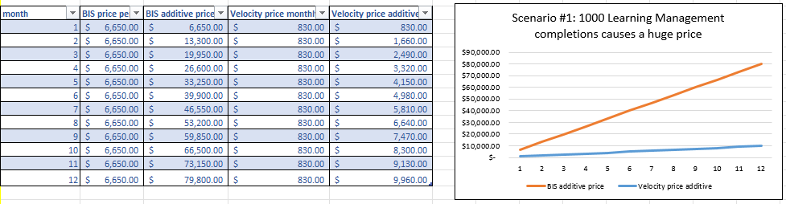

## Scenario 2: Use Digital Forms and Assets in User Based Pricing for 200 Users + Use 2000 Training Records in Transactional Pricing.

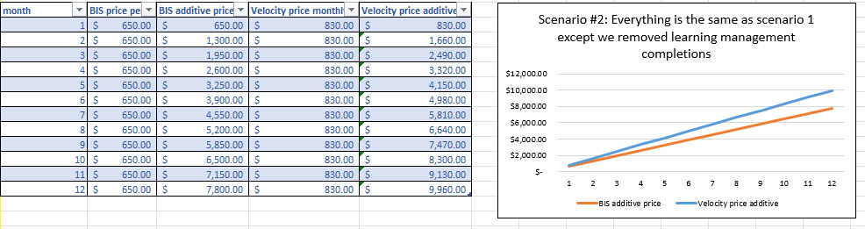

## Scenario 3: Use Digital Forms and Assets in User Based Pricing for 500 Users + Use 2000 Training Records in Transactional Pricing.

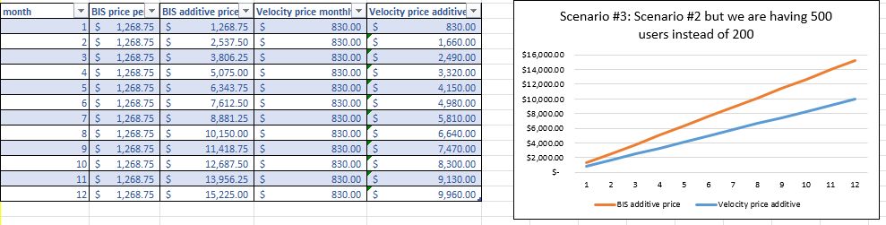

## Scenario 4: Use Digital Forms in User Based Pricing for 500 Users + Use 2000 Training Records and 200 Asset Forms in Transactional Pricing.

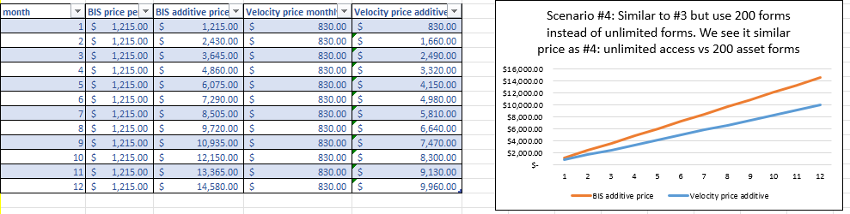

## Scenario 5: Nothing in User Based Pricing + Use 2000 Training Records, 500 Digital Forms, and 200 Asset Forms in Transactional Pricing.

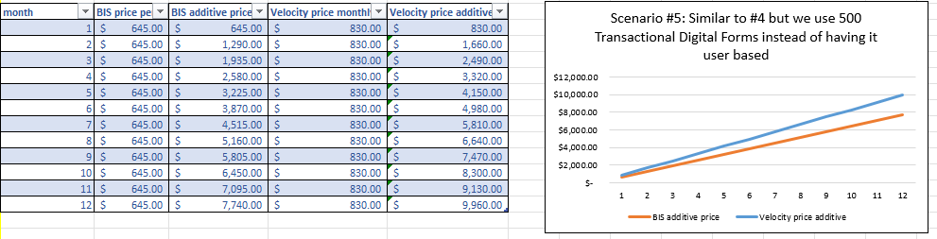

## Scenario 6: Use Training Records in User Based Pricing + 500 Digital Forms, and 200 Asset Forms in Transactional Pricing.

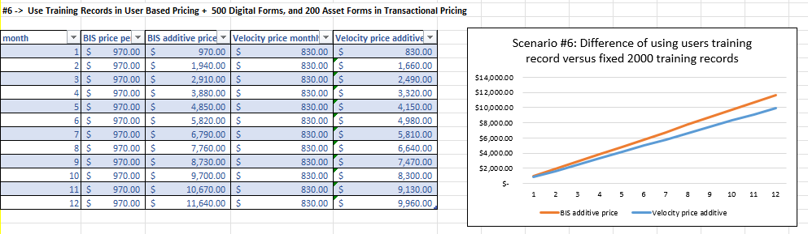

# Appendix 5 - Pros and Cons of each Contender based on Collected Surveys